MATLAB Online training & account creation and using MATLAB Online in browser (Cloud)
Steps to create MathWorks account:
- Please visit the MATLAB portal created by MathWorks for NIT Silchar.
Link is: https://in.mathworks.com/academia/tah-portal/national-institute-of-technology-silchar-31488263.html
Alternatively, they can perform below steps:
Please visit www.mathworks.com and select Country – India.
Click on “Log In” at top right as mentioned.
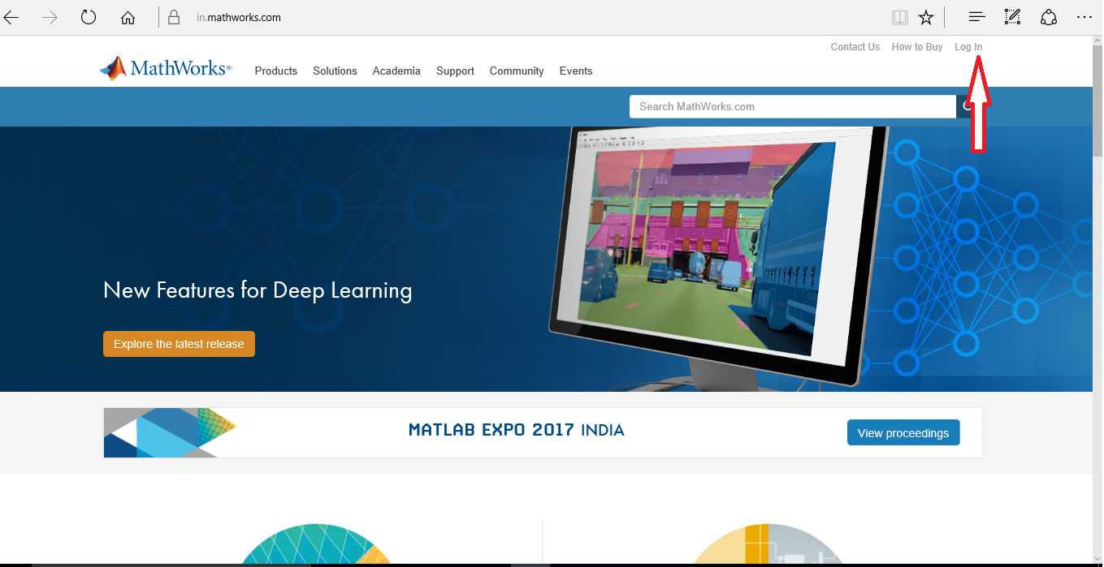

- In next page Click “Create Account”
Pls enter your valid Email ID of NIT Silchar with domain nits.ac.in
Web emails like Gmail, Yahoo, Rediffmail etc are not permitted to access same.
Select Country/ Region as – India
How will you use MathWorks Software – Student use. You can also select “Teaching or Research in School” which is better option if you want to view videos/ webinars later.
Select Yes in Age . Then click Create.
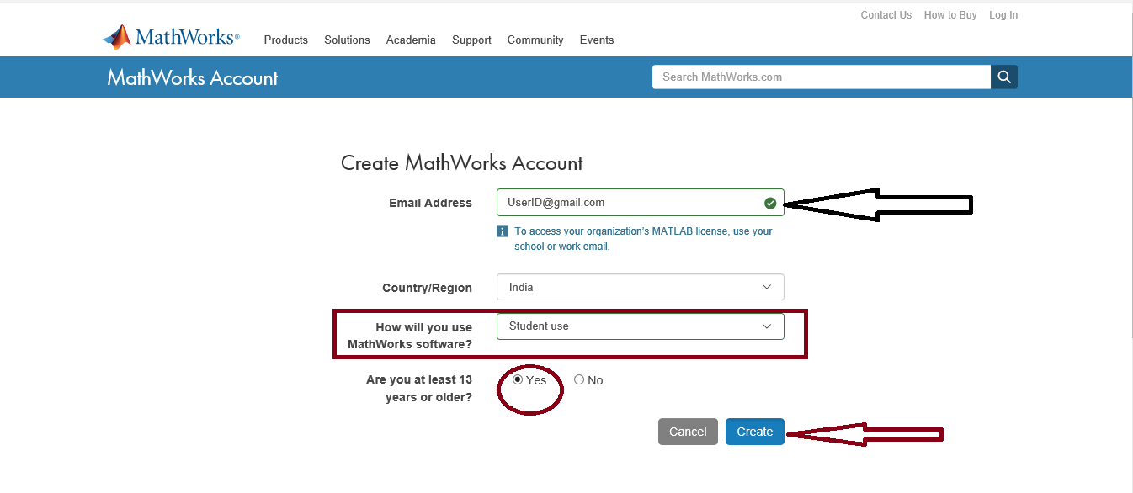

- An Email will be sent by MathWorks to Email address mentioned above to verify the account
Open the email, click on verify or in the Link provided and then change the Login password for MathWorks account. Complete your profile by keying necessary information’s in the page like department, name etc. Once done with profile creation your MathWorks account is ready.

- If any person of NIT Silchar already has MathWorks account with nits.ac.in (and not web emails like Gmail or Yahoo etc) but has forgot his/ her password, then pls Click on “Forgot Password” to Reset the password.

Steps to start using MATLAB Online and MATLAB Online training

- Once students have created their personal NIT Silchar account then pls ask them to look for links
“MATLAB Online “ and ‘ Online Training Courses “
These will be on left hand side of the page in blue font.
MATLAB Online is cloud based and works on browser; so no need to install MATLAB on their systems. They can store their MATLAB scripts, programs in MATLAB Drive inside Online.
The portal link also has the buttons to access same:
https://in.mathworks.com/academia/tah-portal/national-institute-of-technology-silchar-31488263.html
They need to click on below :
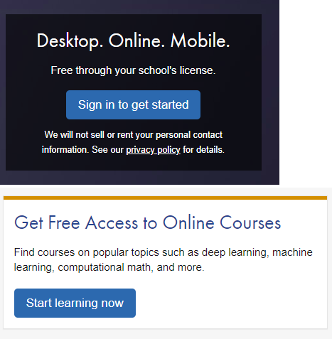
- Insert email ID & password created for accessing MathWorks account using NIT Silchar Email ID.
- Type a Username as per your choice; it should not be an existing one with MathWorks that the website shall inform immediately.
- The free course of MATLAB shall start; at the end of the course each person shall receive a completion certificate in PDF Format.
- Students who are new to MATLAB then they can do the MATLAB Onramp, Deep Learning Onramp, Machine Learning Onramp etc courses. Duration of Onramp course is around 2 hours to 2 hour 30 minutes based on how one takes time to complete. They need to click on each hyperlink from Course overview till Survey; spend time in reading the chapters, descriptions provided and then complete the course by following each task & their corresponding instructions.

Steps to install MATLAB on Laptops/ Desktops

Kindly note MATLAB works well in browser but not Simulink. Hence users in depts. like Electrical, Electronics, Instrumentation, Mechanical who wants to work on Simulink need to install MATLAB.
In case students don’t want to use Simulink then they can work in browser-based MATLAB Online.

- Click on “Download” arrow or “Download” button after clicking the License num: 31488263.

- Start downloading the installer (size around 150 MB) for R2020a latest version.
RAM for installing should be 4 GM (Minimum) with Windows 10 or Windows 7- 64-bit OS.
Recommended RAM is 8 GB; Link for system requirement : https://www.mathworks.com/support/requirements/matlab-system-requirements.html?s_tid=srchtitle

- Pls use option: “Log in with a MathWorks account” as per below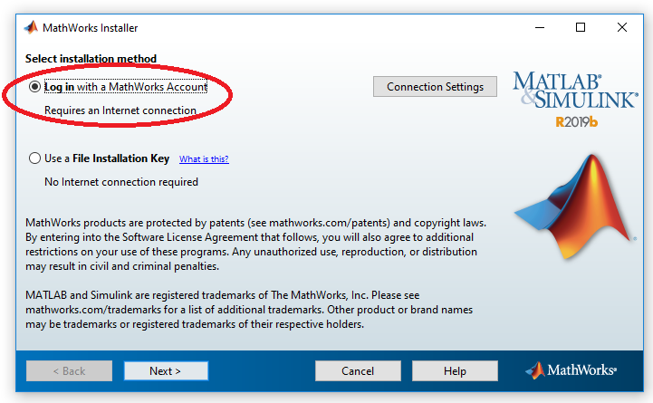
- Let the Installer automatically pick all necessary information’s like Physical address, username etc and keep clicking “next”/ “Accept” wherever applicable.
Do not change the default installation folder which is: C\Program File\MATLAB\.

- Select the products which students need to install. They can choose all products where download size may go upto 25 GB.
It is recommended to download and install those products only which students feel they will use to reduce download size.

- When asked for Activation, let the Installer activate MATLAB using Online by logging to MathWorks account using nits.ac.in email ID/ Password and then selecting the License.

- Once installed, internet is not required, and students can use it wherever they want.

